# File permissions in Linux

Date: 27/01/2025

Nela_officer

## Project description

Manage permissions of files and directories, including hidden ones using basic Linux Bash shell commands

## Check file and directory details

Displays permissions to files in directory projects, for this I used the ls -la command that includes hidden file.

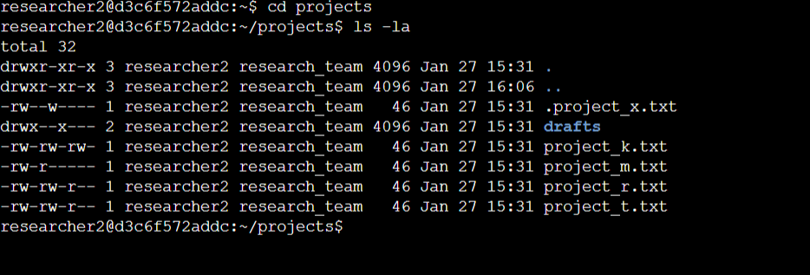

* The first block of the text is a 10-character string that begins each entry indicating how the permissions on the file are set.
* The second block of text in the expanded directory listing is the user who owns the file.
* The third block of text is the group owner of the file.

## Describe the permissions string

In the /home/researcher2/projects directory, there are five files with the following names and permissions:

* project_k.txt -rw-rw-rw-
  + User = read, write,
  + Group = read, write
  + Other = read, write
* project_m.txt -rw-r-----
  + User = read, write
  + Group = read
  + Other = none
* project_r.txt -rw-rw-r--
  + User= read, write
  + Group = read, write
  + Other = read
* project_t.txt -rw-rw-r--
  + User = read, write
  + Group = read, write
  + Other = read
* . project_x.txt -rw--w---- (hidden file)
  + User = read, write
  + Group = write
  + Other = none

There is also one subdirectory inside the projects directory named drafts. The permissions on drafts are: drwx--x---

* User = read, write, execute
* Group = execute
* Other = none

## Change file permissions

Check whether any files in the projects directory have write permissions for the owner type of other:

* The project_k.txt file has write permission for the other user.
* I changed the permissions of the file project_k.txt using the command chmod o-w project_k.txt , with this the other user doesn’t’ have write permission on the file.

The file project_m.txt is a restricted file and should not be readable or writable by the group or other; only the user should have these permissions on this file.

* I used the command chmod g-r project_m.txt to change permissions of the project_m.txt file so that the group doesn’t have read or write permissions:
* 

## Change file permissions on a hidden file

Ddetermine if a hidden file has incorrect permissions and then change the permissions as needed. This action will further remove unauthorized access and strengthen security on the system.

The file .project_x.txt is a hidden file that has been archived and should not be written to by anyone. (The user and group should still be able to read this file.)

1. Check the permissions of the hidden file .project_x.txt
2. Change the access using the command chmod u-w,g-w,g+r .project_x.txt. In this case we remove the access to write to users and group and give access to group for read.

## Change directory permissions

Check the group permissions of the directory of the /home/researcher2/projects/drafts directory and then modify the permissions as required.

Only the researcher2 user should be allowed to access the drafts directory and its contents, this means that only researcher2 should have executed privileges

1. Check the permissions of the drafts directoryusing the command ls – la.That is: drwx—x--- it means that the user can read, write and execute and group can execute.

2 Use command chmod g-x drafts to remove the execute access to group in the directory drafts

## Summary

I manage authorization in Linux using basic Linux Bash shell commands to

* Examine file and directory permissions,
* Change permissions on files, and
* Change permissions on directories
* Manage permissions of hidden files and directories